~Troubleshooting tools:
- Open the command prompt and use the ipconfig tool to find your computer's IPv4 address and default gateway, then take a screenshot of the output.
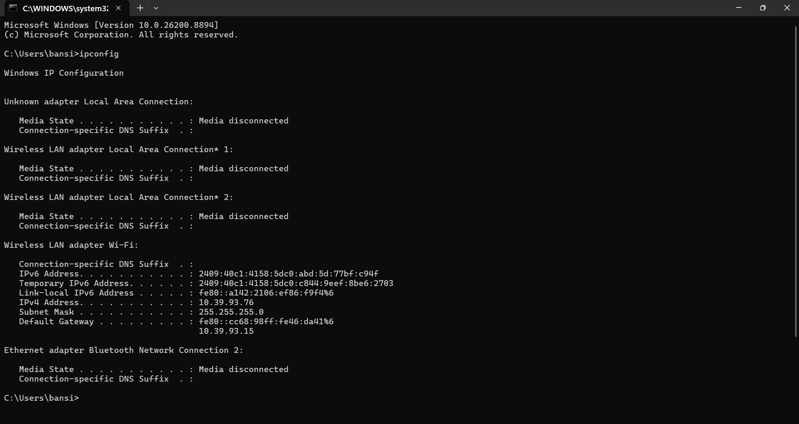

Steps:
- Press Windows + R.
- Type cmd and press Enter.
- In Command Prompt, type:
ipconfig
- Press Enter.
- Look for your active network adapter (Wi-Fi or Ethernet) and note:
  - IPv4 Address (e.g., 192.168.1.105)
  - Default Gateway (e.g., 192.168.1.1)

My output:
IPv4 Address. . . . . . . . . . . : 10.39.93.76
Subnet Mask . . . . . . . . . . . : 255.255.255.0
Default Gateway . . . . . . . . . : fe80::cc68:98ff:fe46:da41%6
10.39.93.15

2.)Use the ping command to check the connectivity between your computer and www.google.com, then note down the average response time shown.
Steps:
- Press Windows + R, type cmd, and press Enter.
- Type the following command and press Enter:
ping www.google.com
- Wait for the command to finish.
- Look at the Ping statistics section at the bottom.

Output:
Pinging www.google.com [2001:4860:4827:7700::] with 32 bytes of data:
Reply from 2001:4860:4827:7700::: time=43ms
Reply from 2001:4860:4827:7700::: time=65ms
Reply from 2001:4860:4827:7700::: time=29ms
Reply from 2001:4860:4827:7700::: time=61ms

Ping statistics for 2001:4860:4827:7700:::
Packets: Sent = 4, Received = 4, Lost = 0 (0% loss),
Approximate round trip times in milli-seconds:
Minimum = 29ms, Maximum = 65ms, Average = 49ms
3.)Run the tracert (or traceroute on Linux/Mac) command to www.flipkart.com and list the number of hops it takes to reach the destination.
Steps:
- Open Command Prompt.
- Type:
tracert www.flipkart.com
- Press Enter and wait for the trace to complete.
- Count the numbered lines (hops) until you reach the destination.

Output:
Tracing route to flipkart.com [64:ff9b::a335:4c56]
over a maximum of 30 hops:

1 19 ms 5 ms 6 ms 2409:40c1:4158:5dc0::6e
2 * * * Request timed out.
3 54 ms 22 ms 41 ms 2405:200:5210:3:3925::ff02
4 29 ms 30 ms 37 ms 2405:200:898:3632:62::7
5 66 ms 45 ms 19 ms 64:ff9b::c0a8:e3c2
6 75 ms 21 ms 30 ms 64:ff9b::c0a8:f486
7 * * * Request timed out.
8 * * * Request timed out.
9 * * * Request timed out.
10 106 ms 47 ms 50 ms 64:ff9b::73f7:6686
11 * * * Request timed out.
12 * * * Request timed out.
13 * * * Request timed out.
14 * * * Request timed out.
15 74 ms 85 ms 64 ms 64:ff9b::a335:4c56

Trace complete.
1.) Destination: www.flipkart.com
2.) Total Hops: 15

3.) Use the nslookup tool to find the IP address of www.spotify.com and explain in one line what this tool helps you verify.

Command:
nslookup www.spotify.com
Output:
Server: UnKnown
Address: 10.39.93.15

Non-authoritative answer:
Name: atc.spotify.map.fastly.net
Addresses: 2a04:4e42:31::810
151.101.211.42
Aliases: www.spotify.com
Observation:
- IP Address : 10.39.93.15
One-Line Explanation:
nslookup helps verify that a domain name (such as www.spotify.com) is correctly translated into its corresponding IP address by the DNS server.

5.) A friend says they cannot access Zomato’s website from their laptop. Suggest a sequence of three troubleshooting commands (choose from: ping, ipconfig, tracert, nslookup) you would run to diagnose the issue, and briefly state what each command would help you check.<br><br><em><strong>Hint:</strong> Think about checking both network connectivity and DNS resolution.</em>

Troubleshooting Commands for Accessing Zomato:
- ipconfig :
  - Checks the computer's IPv4 address, subnet mask, and default gateway to verify the network connection is configured correctly.
- nslookup www.zomato.com :
  - Checks whether the DNS server can resolve the Zomato domain name into an IP address.
- ping www.zomato.com :
  - Tests whether the computer can reach Zomato's server and measures the response time to verify network connectivity.
These three commands help determine whether the issue is caused by local network configuration, DNS resolution, or Internet connectivity.

THE END…..

